**Lab Practical #05:**

Study the concept of VLAN using packet tracer.

**Practical Assignment #05:**

1. **Implement the different network structures in VLAN and VLAN trunking. Also check connectivity between them using ping command or PDU utility.**

**Instructions:**

1. Different VLANs configuration setup screenshot. (VLAN example given by lab faculty)

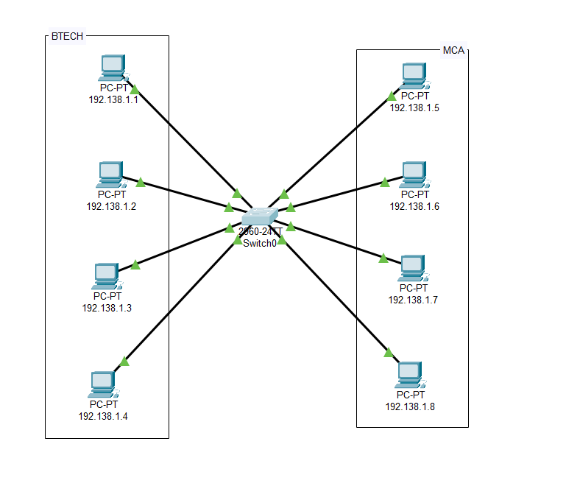

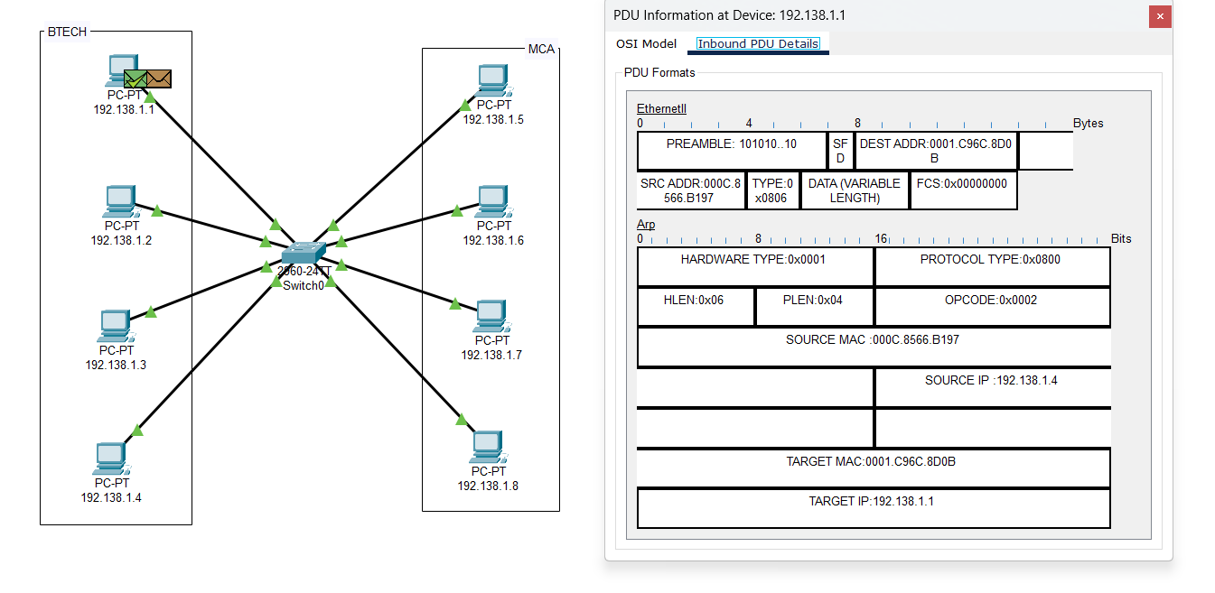

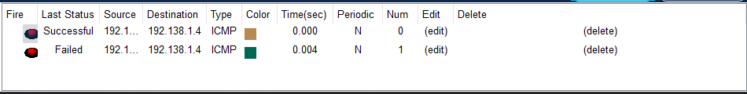

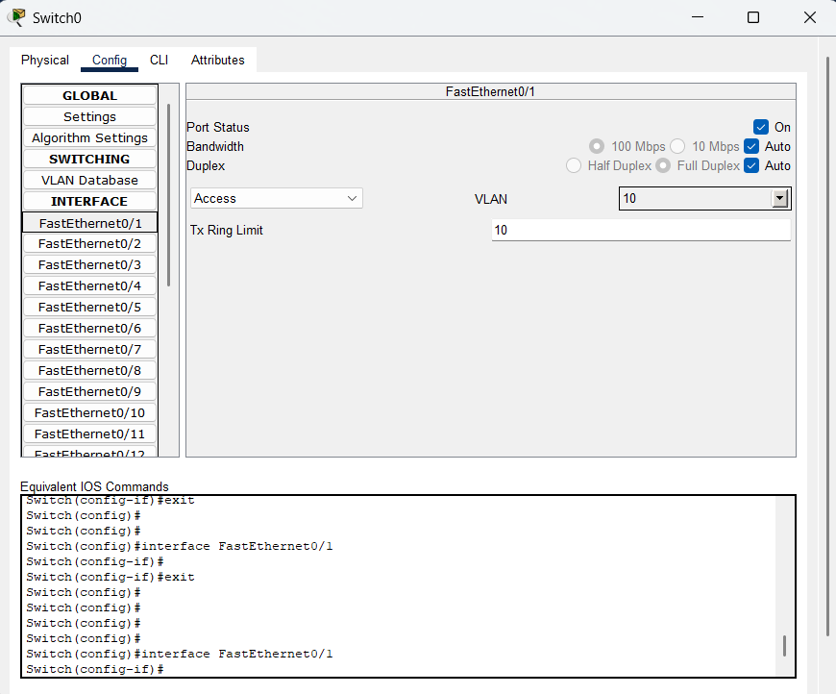

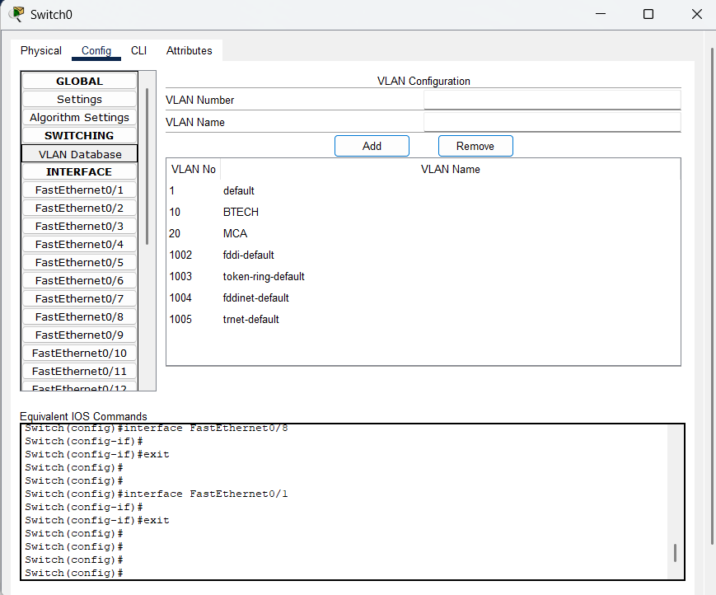

1. Write steps to create VLANs in packet tracer.

enable

configure terminal

vlan 10

name BTECH

vlan 20

name MCA

exit

-----

interface range fa0/1

switchport mode access

switchport access vlan 10

----

interface range fa0/2

switchport mode access

switchport access vlan 20

--------------

interface range fa0/3

trunk

exit

1. Mention IP address of each pc as label.

* IP Address: 192.138.1.1

1. Ping command or PDU screenshot between two VLANs.

